OPPDRETTERKLASSE NV 2022 / 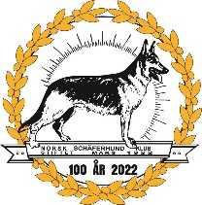
BREEDER CLASS NV 2022
PÅMELDINGSSKJEMA / REGISTRATIONFORM

Oppdrettets navn / The breedings name:
_____________________________________

Antall individer / Number of individuals: ________

Katalog nr. / Catalog no.: ___________________________________
___________________________________

Antall kombinasjoner / Number of combinations: ________________

Antall hanner / Number of males: ____________________
Antall tisper / Number of bitches: ____________________

Antall fedre / number of fathers: ________________
Antall mødre / Number of mothers: ________________

Antall i Brukshundklasse / Number of dogs in Working Dog Class:
_____________

____________________________
Signatur / Signature

